International Alliance of Protected Areas

Operation Guide Series

(For Protected Area Managers)

Monitoring Planning Operation Guide
for Protected Areas



Issued in 2018
Updated in September 2018
International Alliance of Protected Areas (IAPA) was proposed by Changbai Mountain National Nature Reserve of China in 2013. With strong support of Jilin Provincial Forestry Department and Changbai Mountain Conservation and Development Management Committee, IAPA was officially established in 2014 and affiliated to the International Society of Zoological Sciences (ISZS). It unites protected areas (PA) in the world to promote coordination, collaboration and cooperation among PAs at national, regional and international levels; promote species surveys and monitoring, trans-regional conservation, and mitigating the impact of global climate change on biodiversity; strengthen conservation publicity and education, explore friendly development strategies in PAs and surroundings, and promote combating environmental crime at site. It becomes a platform for improving management effectiveness of PAs to achieve the goal of harmonious development between man and nature. The first five IAPA annual meetings were held in Changbai Mountain, Shennongjia and Tangjiahe national nature reserves of China. By September 2018, there are 93 PA members (27 from outside of China).

IAPA Operation Guide Series are especially designed for PA managers, and kept short, practical and linked to the best and most recent guidelines in the world. It will be reviewed and updated constantly along with practices. Revisions are welcome and suggestions please send to: cbm_iapa@126.com

Recommended Citation:
Xie Y, MacKinnon J, Gan XJ, Yang WH, Leempoel K (eds.). Issued in 2018 and updated in Sept. 2018. Monitoring Planning Operation Guide for Protected Areas. IAPA, Beijing, China. Available from http://www.iapa.pub (Accessed in __________).

The operation guide is prepared by following organization:
The Global Protected Area Friendly System (GPAFS) was initiated in 2013 by the task force of Institute of Zoology, Chinese Academy of Sciences and encouraged by the 6th World Conservation Congress, to bring together scientists, entrepreneurs, civil organizations, and the public to support, promote and participate in new production models that are beneficial to nature conservation in and around PAs, to stop the decline in global biodiversity, and to ease the biodiversity loss crisis that threatens humanity’s safe operating space. More information found in www.gpafs.net.


Monitoring Planning Operation Guide for Protected Areas

Yan Xie, John MacKinnon, Xiaojing Gan, Weihe Yang, Kevin Leempoel

Contents
1. The importance of monitoring 3
2. The general principles of monitoring 5
3. Indicators 6
4. Biodiversity monitoring 8
ACTION 1. Assessing biodiversity values and potential biodiversity impacts 10
ACTION 2. Establishing a baseline 10
ACTION 3. Focusing on significant impacts to identify monitoring targets 10
ACTION 4. Generating list of potential indicators 10
ACTION 5. Choosing indicators 11
ACTION 6. Developing and implementing monitoring plan on selected indicators 11
ACTION 7. Reporting for Communicating and Guiding Management 11
ACTION 8. Reviewing and modifying actions 12
5. Analyzing and reporting monitoring data 12
5.1 Minimize bias 12
5.2 Use clear graphics 13
5.3 What is a correlation? 15
5.4 Longer-term data histories 16
6. Useful PA monitoring tools 16
6.1 Rapid Assessment Program Approach (RAP) 16
6.2 Technical references for biodiversity survey and monitoring 17
6.3 Management Effectiveness Tracking Tool (METT) 18
6.4 Ecosystem Health Index (EHI) 18
6.5 Spatial Monitoring and Reporting Tool (SMART) 19
6.6 Ecotourism guidelines 19
6.7 Knowledge, Attitude and Practices (KAP) survey 20
6.8 Rural Rapid Appraisal (RRA) and Participatory Rural Appraisal (PRA) 20
6.9 Remote sensing technology for biodiversity monitoring 20
6.10 Conservation genetics 20
Acknowledgements 21
Reference 21

1. The importance of monitoring
Monitoring is basically the repeated observation of variables within a system in order to detect signs of change. Monitoring can be used to quantify change, identify the causes of change and inform acceptable levels of change.

Monitoring in Protected Areas (PA) includes both human (socioeconomic) and biophysical (ecological) aspects of monitoring. Socioeconomic monitoring normally focuses on people’s knowledge and attitude towards an ecosystem/species as well as their natural resource use and dependence. Ecological monitoring on the other hand will generally focus on a specific species or ecosystem, using supporting information on environmental conditions and associated organisms. Together, they provide a picture of the human and environmental changes which take place over time in a particular place, how they are interlinked and how management can be improved in order to address socioeconomic and ecological changes and threats. Monitoring should also include performance monitoring, which is evaluation on management effectiveness, including management measures, legislation, policy, community development plan, donations and planning outcomes.

A key aim of carrying out monitoring is to improve management practice and to ensure that it is well-informed by the situation on the ground and responsive to it. The PA management plan sets out specific goals and objectives which may include scientific information and research, active management and sustainable utilization of species and ecosystems, plans for tourism development, and local participation in park management. Monitoring can provide useful information for planning and implementing all of these management decisions, including (Sriskanthan et al. 2008).

Systematically, the importance of monitoring are as mentioned below:
1) To provide information for sustainable management of natural resources
This can include the planning of sustainable fishery yields and forest product extraction rates. Monitoring can support decisions regarding the zoning of resource areas to ensure the sustainability of extraction, for example through pinpointing areas that should be used for extraction, areas that should be allocated for regeneration, and areas that could be utilized for multiple purposes. Monitoring allows managers to determine whether specific management interventions are achieving the desired conservation goals and adapt management accordingly. Monitoring also supports understanding of the economic value of natural resources. This is important knowledge for decision makers who need to plan the wise use of finite resources.

2) To determine changes and threats to ecosystems
Monitoring can be used to support Environmental Impact Assessments and Risk Assessments, allowing managers to better understand where potential changes and threats to ecosystems originate from so that they can make management decisions in order to mitigate or minimize the unwanted impact of these. It also allows them to manage invasive alien species that may threaten native species and ecosystems.

Long term monitoring is important to understand natural ecosystem fluxes. The example from Kruger National Park is that there are climatic cycles of more or less 10 years drought (El Nino driven) and 10 years wet periods (La Nina driven) which form part of the natural flux pattern and heterogeneity. Before this was understood managers did immeasurable damage to the PA by provision of artificial water to counteract droughts, and also initiated culling programs, veld burning programs with thousands of kilometers of firebreaks, etc. Monitoring must therefore aim to assist with "know and understand your ecosystem, and don't panic". Some long term monitoring programs such as South African Environmental Observation Network (SAEON), International Long Term Ecological Research (ILTER), US Long Term Ecological Research Network, National Ecosystem Research Network of China (CERN) etc. would help providing information to individual PAs.

3) To track changes in people’s knowledge, perception and use of biological resources
Achieving sustainable use of ecosystems and their services will often require enhancing people’s understanding of the benefits and values being provided by an ecosystem and its services, as well as altering extraction practices.

4) To plan and implement restoration activities
Monitoring provides us with the information that we need to develop recovery programs for endangered species or damaged ecosystems. Monitoring is essential to guide activities relating to ecosystem rehabilitation and replanting/regeneration, and would enable managers to determine the outcome (success/failure) of active restoration work.

5) To facilitate the formulation and implementation of conservation legislation and policies based on scientific information
The above knowledge is essential for policy makers and managers, who require science-based information in order to make the best governance, policies and management decisions for wise and sustainable ecosystem management.

6) To develop nature-based tourism
Information generated can be used towards developing and promoting nature-based tourism, In particular, the impact of number of tourists on ecosystem and zoning management for tourism. These activities can in turn generate money and resources that can be invested in future species and ecosystem management.

7) To contribute towards education and public awareness on conservation
Monitoring can contribute to educational and awareness programs, increasing knowledge about key species or ecosystems. Monitoring can also be conducted in partnership with students and the public, thereby involving them in the process of management and learning.

2. The general principles of monitoring
Monitoring is a big and important job but the manager only has a limited budget and manpower to invest in monitoring. Therefore, it is not realistic to be able to monitor every plant and animal species in a PA, or to look at every single health, income, welfare and livelihood indicator for the whole population in and around PA. Therefore, managers need to be very efficient in selecting meaningful elements to monitor and identifying cost-effective methods to do this. Biologists have developed hundreds of different methods for field surveys, tailored to specific problems posed by different species and different natural conditions. This guide does not specify these approaches, but rather helps managers to identify what protection and management issues they want to address, and to select appropriate indicators for monitoring the problem. Once specific indicators are determined, managers need to look for technical methods to monitor related indicators. This guide lists only the general principles applicable to all monitoring activities, as well as important technical guidelines and documentation available for reference in Section 6. IAPA will continuously update this guide, improve it in practice, and update published monitoring technical references.

Many entire books are devoted to this subject but most methods are variants of some classic standard approaches. To start with managers need to be clear what questions they want to address.

What? The PA manager needs to know what he or she is dealing with - what ecosystems, what species, what problems. He/she probably needs a basic qualitative inventory or stock-taking survey.
How many? Counting takes a lot of time and is difficult. The manager needs to select which species or aspects really require quantified assessments.
Where? Biota are not distributed evenly across a site. Surveys must establish which spots or habitat types are important for different species.
Patterns of change? Monitoring the population trend of a species is often more important than knowing the exact number. This is the only way to assess impacts on status over time.
Why? The PA manager often needs to know why changes are occurring but identifying the causes of natural processes is quite complex and often indirect. This may require professional analysis and specialized research.

Different types of monitoring are needed for different purposes. Here are some examples:
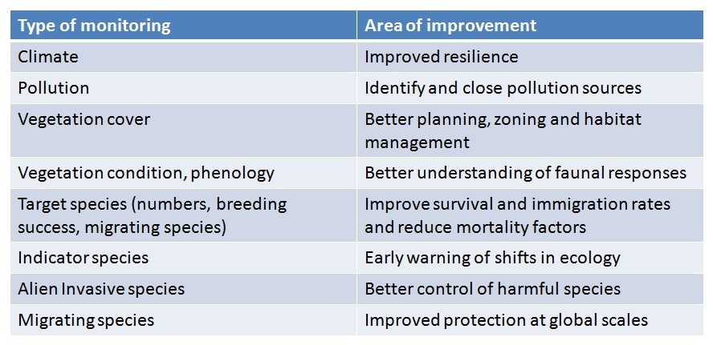

3. Indicators
Indicators are ways of presenting and managing complex information in a simple and clear manner that can form the basis for future action and can be readily communicated to internal or external stakeholders as appropriate. Although individual indicators vary, “good” indicators follow the SMART philosophy (Specific, Measurable, Achievable, Relevant and Timely). Tracking changes in these key indicators provides a picture of trends and changes in the broader system.

Indicators can be divided into three following categories:
- Environmental physical and chemical indicators: water form, water quality, soil physical and chemical indicators;
- Human activity indicators: planting agriculture, logging, collection, aquaculture, grazing, traffic facilities construction, pollutant discharge, water conservancy engineering, sand quarrying, fishing, alien invasion, tourism, illegal behavior, attitude consciousness, etc.
- Biodiversity indicators: number of species (species richness), population abundance of species, biodiversity index, number of endemic species, number of protected or endangered species, number of important resource species, invasive degree of alien species, degree of vegetation damage, etc.

Numerous indicators have been developed to monitor environmental and sustainable development issues. Fewer (but still numerous) indicator-suites are recommended specifically for measuring biodiversity. Biodiversity indicators are more complicated and highly relevant to PA management. Therefore, the guidelines section here focuses on biodiversity indicators, and for other socio-economic and environmental indicators, please refer to the references introduced in the chapter 6. In addition to the SMART philosophy, biodiversity indicator should also be (The Energy & Biodiversity Initiative, 2018):

- Simple and relate to something that people can understand and use.
- Able to address a need (e.g., be established through stakeholder dialogue or respond to a predicted significant impact).
- Sensitive to anthropogenic impacts – able to measure changes caused specifically by humans (i.e. able to differentiate between long-term background changes and those changes arising from the presence of utilization).
- Dynamic and responsive to ongoing changes.
- Able to address positive and negative changes.
- Spatially relevant across the required geographical level (i.e. local, regional, global).
- Valid and reliable using technically defensible measurement techniques.
- Cost-effective and involve the appropriate level of effort.
- Policy relevant (easy to interpret, showing trends over time against baseline or reference values, and influences decisions).
- Able to address priorities and the issues of greatest importance.
BOX 1. THE LIMITATIONS OF BIRDS AS BIODIVERSITY INDICATORS

BirdLife International has been researching and using birds as indicators of biodiversity for decades. Data from the work associated with birds from many organizations has been collated to give an understanding of threatened and endangered birds, endemic bird areas and Important Bird Areas. There are both positive and negative aspects of using birds as indicators species:

Appropriate Use Scenarios | Limited Use Scenarios
Birds are a good taxa for data collection: relatively easy data to collect, and people can be trained to spot presence and absence. | If only measuring birds, may not pick up changes that birds are not susceptible to (i.e., it is unwise to extrapolate from one situation to another).
Priorities have been established (Globally Threatened  Birds, IBAs, IUCN red data list, etc.). | May encourage a management focus on one or more bird species that does little or nothing to enhance overall biodiversity conservation.
Their behavior and interaction with the environment can be a good indicator of ecosystem health, i.e. they need plants, insects, nesting sites, water, etc. | May or may not be sensitive to a particular company activity.
Governments use them as indicators, e.g. UK use of skylark, presence and absence. | May provide misleading information, e.g. migratory species may be impacted by a wide range of detrimental environmental conditions, away from the site.
Good as a combined indicator with other aspects, e.g. plants. | The number of birds resting or wintering may not be a good indicator of impact.

The absence of one or more of these preferred characteristics may lead to limitations in how the indicators can be developed and used. Some common limitations are shown in Box 1 (The Energy & Biodiversity Initiative, 2018), using birds as an example. The key here is that, in deciding to use birds as an indicator, they help answer a direct question and are used appropriately, in the correct context. Box 2 shows the contents and frequency of some bird indicators in Dongting Lake.
Box 2: Example of indicator species for Dongting Lake with rationale

Species | Indicates | Reasons for decline | Incidence of sampling
Common Kingfisher | Water clarity, small fish density, low human disturbance in shallow water | Water turbidity, lack of fish, high disturbance, some seasonal changes expected | Monthly counts along sample waterways
Cormorant | Large fish density and low human disturbance | Low fish stocks and human disturbance, lack of roost trees | Monthly counts at known roost sites
Grey heron | Large fish density at edges of waterways | Reduction of prey and high human disturbance | Monthly counts at sample points and transects
Egrets | Ecological health of agricultural fields and wetlands | Lack of prey in fields due to overuse of insecticides and pollution | Monthly counts at sample roosts year round
Long-tailed Shrike | Ecological health of agricultural lands year round | Lack of prey in fields due to overuse of insecticides | Monthly Counts along sample counts year round
Pintail duck | General water fowl suitability | Human disturbance and reduced lake condition | Monthly counts through winter
Dragonflies | Year round water quality and ecological health | Overuse of insecticides or pollution | Weekly counts on sample ponds and banks
Moths | Diversity and health of terrestrial flora | Low plant diversity and levels of insecticides | Moth traps, weekly

4. Biodiversity monitoring
This section sets out a sequence of eight actions that lead to the biodiversity monitoring(The Energy & Biodiversity Initiative, 2018). Figure 1 summarizes the sequence of actions, along with the input(s) necessary to carry out each action, and the output(s) resulting from that action. Some of these stages will occur concurrently, some consecutively but all are underpinned to some extent by stakeholder engagement.

The following working procedures for regular and long term monitoring should be adopted. All data collected should be compared with baseline data -- A set of data serving as a basis, as for measurement, calculation, or location. The monitoring implementation should be reviewed every 2-3 years to ensure the selected indicators are still highly relevant to local conditions and conservation management goals, and also update the baselines.

The monitoring procedures can be divided into following actions:

ACTION 1. Assessing biodiversity values and potential biodiversity impacts from available sources
ACTION 2. Establishing a baseline
ACTION 3. Focusing on significant impacts to identify monitoring targets
ACTION 4. Generating a list of potential indicators
ACTION 5. Choosing indicators
ACTION 6. Monitoring of impacts of management
ACTION 7. Reporting for communicating results and guiding management
ACTION 8. Reviewing and modifying actions

FIGURE 1. Procedures for biodiversity monitoring (The Energy & Biodiversity Initiative, 2018)

ACTION

ACTION 1. Assessing Biodiversity Values & Potential Impacts
OUTPUT

Biodiversity value

Low High

CONSIDER EXITING INDICATOR PROCESS ACTION 2. Establishing a Baseline
ACTION 3. Focusing on Significant Impacts
Zero

ACTION 4. Generating a List of
Potential Site-Level Indicators

ACTION 5. Choosing Indicators
ACTION 6. Monitoring of Impacts
ACTION 7. Reporting Performance

ACTION 8. Reviewing & Modifying Activities

Zero

Potential biodiversity impacts

More than Zero

Significant impacts
More than Zero

CONSIDER EXITING INDICATOR PROCESS Preliminary targets

Revised targets

ACTION 1. Assessing biodiversity values and potential biodiversity impacts
This is the starting point for the process of indicator development. It begins with an assessment of biodiversity value of the PA, drawing from available literature. This establishes in general terms the nature of any biodiversity values that may be present and potentially affected by external threats. Stakeholder analysis and subsequent engagement (for example, with local communities, regional/national government departments and local/national conservation NGOs) should be used to assist in understanding the context within which potential impacts may occur. This also helps to develop the reasoning behind why indicators should be developed and used.

ACTION 2. Establishing a baseline
Baselines are useful snapshots of initial conditions of resources against which change in status can be compared. There are many approaches to establishing a baseline, such as the Rapid Assessment Program (see 6.1) created by Conservation International and the Rapid Ecological Assessment program created by The Nature Conservancy. The involvement of experts to identify the biodiversity of the area via on-the-ground surveys can be a key means of establishing the baseline state of the ecosystem – bearing in mind that the area may have already been impacted by human activity and that biodiversity varies through time. Equally, a particular survey period may or may not be representative. Therefore, the design methodology is very important. Good design can ensure that data collected are the most relevant to management objectives. The use of existing literature (such as IUCN lists, National/Local Key Protected Species or Action Plans, Hotspots, WWF Ecoregions, Endemic Bird Areas, Important Bird Areas, Centres of Plant Diversity and nationally designated protected areas) can assist in identifying key habitats/species that may be at risk and their current condition.

ACTION 3. Focusing on significant impacts to identify monitoring targets
The inputs to Action 3 are the preliminary analysis of biodiversity values and the full list of potential impacts derived from Action 1, the biodiversity baseline (if undertaken) that establishes the context for understanding which of the potential impacts are significant and an appropriate site-level risk assessment process as a means of defining the significant impacts. The outputs from Action 3 are a quantitative or qualitative description of what the indicators will relate to (e.g. the indicator context in terms of area or region, or corporate unit) and a smaller group of significant impacts derived from the longer list of potential impacts.

ACTION 4. Generating list of potential indicators
Each significant impact on biodiversity identified in Action 3 can generate one or more potential indicators. Appropriate targets would be established through stakeholder engagement and scientific assessment, and then potential indicators are developed to monitor changes. There is, however, little value in implementing an indicator that does not have at least some level of support among stakeholders. The proposed indicators should be explained to the stakeholders previously consulted, along with the rationale for each of them. If the reasons for measuring particular indicators and their limitations are not communicated, confusion and misuse of the resulting information may follow.

ACTION 5. Choosing indicators
The list of potential indicators generated in Action 4 must now be reduced to a smaller number of the most appropriate indicators. There is no definitive number that is required; the key to the choice of indicators is that they are SMART, based on suitability to address the measurement objectives and ability to monitor the results of modifying activities. Use questionnaires, meetings with groups and individuals, structured interviews with stakeholder representatives or other methods as appropriate to the situation.

ACTION 6. Developing and implementing monitoring plan on selected indicators
Once indicators are selected, a monitoring plan for each of them should be developed. The plan should specify and clearly answer following eight questions:
- Why conduct monitoring?
- Who are the audiences of the monitoring results?
- Who should participate in monitoring?
- What technologies should be used for measuring the indicator?
- What resources (man power and funding) need for measuring the indicator?
- What is the time schedule to conduct monitoring?
- How to manage and analysis data?
- How to communicate evaluation results and use it for decision making?

Answers to these questions should be included into a workplan as a table. The plan will help monitoring members to understand why, how, what time and who is monitoring. It serves as a map and guide to show monitoring members to the destination – comprehensive evaluation of management effectiveness of PAs.

ACTION 7. Reporting for Communicating and Guiding Management
Communicating and reporting performance, as a legal requirement or voluntarily to external stakeholders is an integral part of measuring both impacts and the actions taken to address those impacts (Section 5 gives more detail on data management, analysis and reporting). This is possible at various spatial levels: locally, nationally, regionally or globally, depending on the requirements identified. Types of information and methods of reporting will differ according to the needs of the PA management and the expectations of stakeholders. When externally reporting on biodiversity indicators, it is important to include why these particular measures have been adopted and what process was used to develop them in order to promote transparency.

ACTION 8. Reviewing and modifying actions
It is important to assess the success of actions and indicators put in place. If reporting (Action 7) indicates that performance is not in line with targets, then management activities should be modified as appropriate. The management bureau may also need to periodically assess whether a more suitable indicator exists that will enhance the process of monitoring and improving performance (see Actions 4 and 5).

5. Analyzing and reporting monitoring data
Monitoring data are meaningless in their raw form. They need to be analyzed and presented in ways that managers, leaders, the public, and media can understand, appreciate and act upon. Numbers are meaningless without a yardstick by which to evaluate them. For example, the report that a survey team saw 200 green-headed ducks may be a very accurate fact but is meaningless without scale or context. Is that a lot or a little? Compare the statement 'the team recorded 200 green-headed ducks in 2 hours from 3 stations. This is double the number counted last year and included 50 seen in an area where they were never recorded before'. Suddenly the statistic is given some comparative meaning.

Consider the report that 'we saw 200 green-headed ducks in sector A but only 105 in sector B.' Are readers to infer there are more ducks in area A? They cannot make this conclusion without an idea of search effort. If they knew that the 200 ducks in area A took 50 hours of search at 10 stations whilst the 105 in area B only took 5 hours at 3 stations, they must conclude that in fact there are probably far more ducks in area B. The raw data cannot be fairly compared: the sample for area A is greatly biased by a much greater search effort. Comparing numbers from one sample to another requires presenting the data in comparable units so as much bias as possible is avoided.

5.1 Minimize bias
Try to minimize bias by:
- Replicating conditions of method, sample sites, season, weather conditions, time of day, observer ability
- Using robust methodology
- Selecting commoner species to achieve large sample size
- Standardising search effort
- Using appropriate statistics

Managers should express quantities in terms of comparable search effort such as mean rate of encounter, number seen per km walked, number seen per hour of observation, or number caught in 10 net days. Even these units may be biased if observation conditions in one site are quite different from another. In the latter case managers may need to use proportional figures like 60% of all duck sightings in area A were green-headed duck, compared to only 40% in area B.

5.2 Use clear graphics
Expressing results in spreadsheets of numbers is also quite meaningless to most readers. Try to represent data in clear graphics. Most managers and leaders are familiar with histograms, pie-charts, time graphs and map insets. These can be used to effectively reveal the results of much survey data.
Provided the scores are comparable, managers can show differences between different time periods, locations or species with simple histograms. The following figure shows such representations (using dummy data).

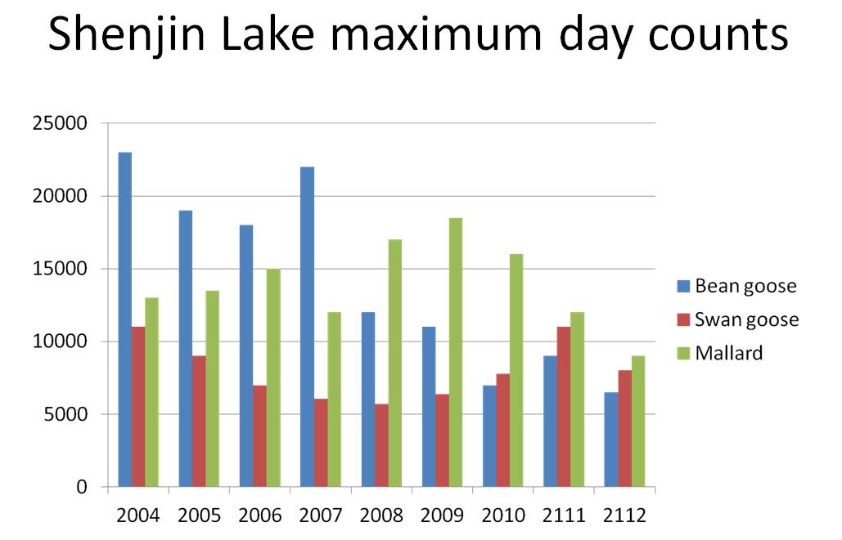

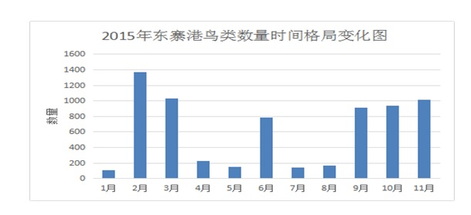
The following data (real) from Dongzhaigang shows many species combined through the year. Notice however the curious spike in numbers in mud summer. This is the presence of nesting herons and egrets and quite different from the peak of migrant waders in winter months.

This shows the need to be careful when combining data from different species. Consider the following real data from annual estimates of the total birds (top line) in United Kingdom compiled over many years.
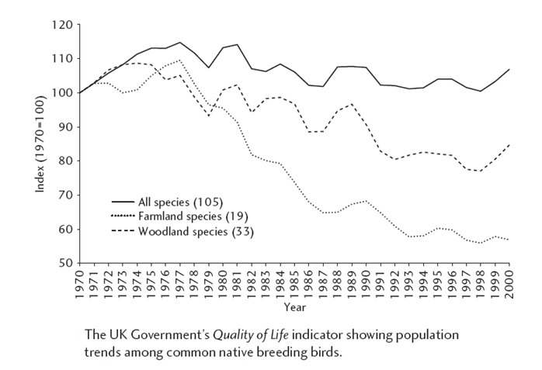

The data show some variation but generally one can conclude that the overall numbers have not changed much. But the lower lines show that hidden in the overall satisfactory picture are serious declines in the numbers of woodland and farmland birds. The data need to be carefully separated to reveal these details.

Spatial comparisons can be shown on a map. The following examples show how to display comparative data of different species or temporal distributions over large areas or a single lake. The last example shows real presentation of levels of human disturbance.
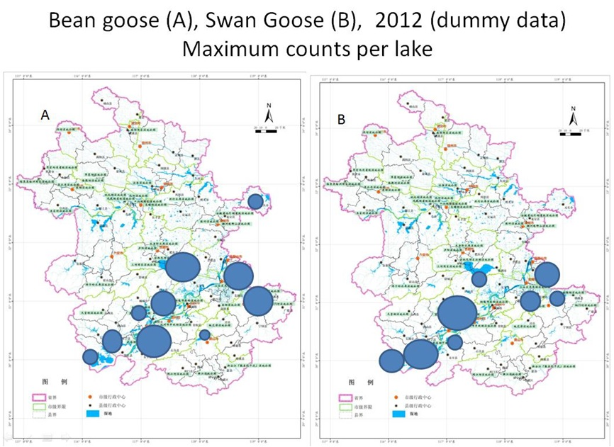

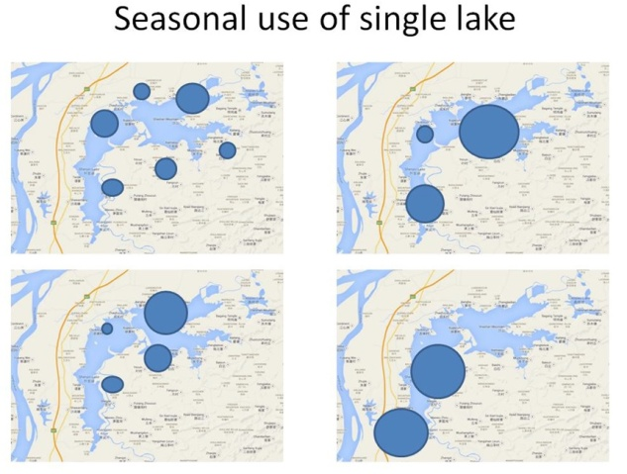
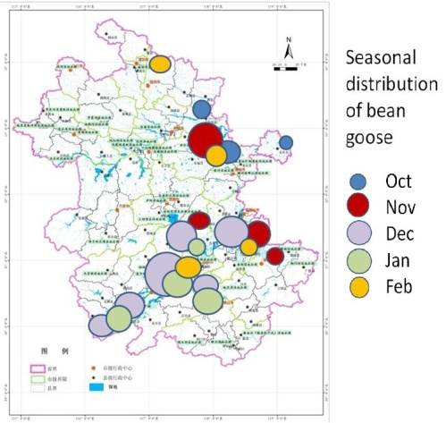

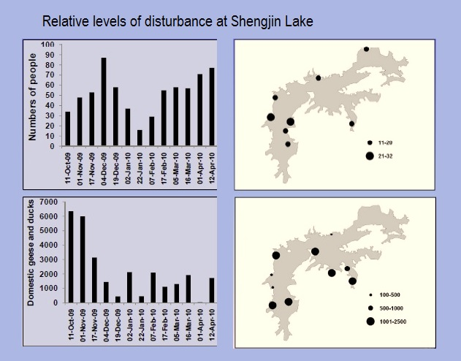
The latter graph raises the issue of correlation. Can data show that the levels of human disturbance affects the seasonal distribution of geese on the lake?

Here managers need to enter the daunting realm of statistical tests.

5.3 What is a correlation?
Correlation tests whether the values for two or more different factors are related. The correlation can be positive, negative, or neutral and it can be very strong or weak. Use of appropriate statistics can give the answers and indicate whether the correlation is significant or not.
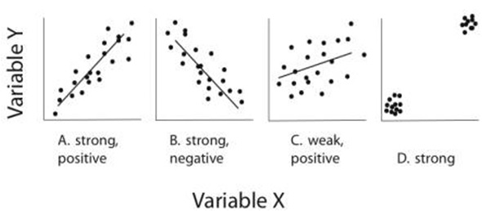

By significant the statistician means that the chances of such a degree of correlation being coincidental and the relationship being bogus are less than 5%.

In the case of a direct comparison between two samples (such as seasonal use of space by two different species) a significant difference signifies that the chances of the two samples being drawn from the same statistical data pool is less than 5%.

Big caveat: A correlation may support the argument that one factor affects another but does not prove causation. Both factors may be varying in response to a third unidentified factor or combination of factors.

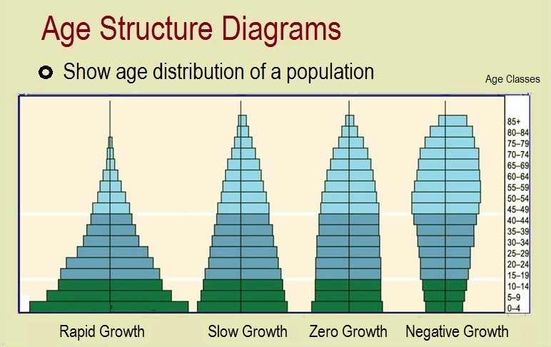
5.4 Longer-term data histories

Whilst the PA manager is mostly dealing with documenting numbers, timings and spatial distributions, other important measurements can reveal interesting data over much longer time periods such as growth rings on trees or age class structures that indicate whether a resident population is stable, increasing or declining.

6. Useful PA monitoring tools

6.1 Rapid Assessment Program Approach (RAP)
The Rapid Assessment Program Approach (RAP) was developed in 1990 by Conservation International to collect biological information and build baseline to inform conservation decision-making. RAP methods are designed to rapidly assess the biodiversity of highly diverse areas, identify the threats to this biodiversity, identify priority areas for conservation, strengthen community involvement and participation in conservation management, train local scientists in biodiversity survey techniques, and to develop management policies and sustainability options. Criteria used to identify priority areas for conservation include: overall species richness, presence of local endemics, rare species, threatened species, and habitat condition. Surveys undertaken for the RAP are often limited to species lists, but sometimes include information on abundance. More detailed information(Patrick, 2014): http://t.cn/R31l5be.

6.2 Technical references for biodiversity survey and monitoring
The most comprehensive reference is the “Handbook of Biodiversity Methods: Survey, Evaluation and Monitoring” published in 2005 (Hill et al., 2005). This Handbook provides standard procedures which will enable practitioners to better monitor the condition of the biodiversity resource, resulting in improved data upon which to base future policy decisions and actions. Organized in three parts, the Handbook first addresses planning, covering method selection, experimental design, sampling strategy, and data analysis and evaluation. The second part describes survey, evaluation and monitoring methods for a broad range of habitats. Part three considers species and provides information on general methods before addressing specific methods of survey and monitoring for the major taxonomic groups. It covers taxonomies of Fungi, Lichens, Bryophytes, Aquatic macrophytes and algae, Vascular plants, Dragonflies and damselflies, Butterflies, Macromoths, Other terrestrial invertebrates, Aquatic invertebrates, Fish, Amphibians, Reptiles, Birds, Bats, Other mammals.

The book of “Ecological Census Techniques” (Sutherland, 2006) introduces Planning a research program, Principles of sampling, General census methods, Plants, Invertebrates, Fish, Amphibians, Reptiles, Birds, Mammals, Environmental variables, The twenty commonest censusing sins.

The Multiple Species Inventory and Monitoring (MSIM) protocol (Manley et al., 2006) is intended to serve as a consistent and efficient method for obtaining basic presence/absence data and associated habitat condition data for a large number of individual species at sites that represent a probabilistic sample. It is designed to be implemented in association with Forest Inventory and Analysis (FIA) grid points on National Forest Service (NFS) lands. The MSIM protocol is designed as a base monitoring approach on which regions and forests can build to meet their specific National Forest Land and Resource Management Plan monitoring needs with the greatest possible efficiency (measured as the amount of useful and high-quality information gained per unit cost).

In addition to the above references, some references for species survey and monitoring techniques are listed here.

Taxonomic Group | Reference
Herpetology | Fisher et al., 2008 (pitfall trapping); Martin, 2011 (anuran tadpoles)
Bats | Ellison, 2008 (Bat Banding); Hoffmann et al., 2010 (Trapping methods);
Large mammals | Hines et al., 2010 (occupancy modeling); Kays et al. 2009 (Camera traps); MacKenzie et al. (2002); Stephens et al. 2006 (Track counts)
Mid-sized mammals | Hoffmann et al., 2010 (Trapping methods)
Small mammals | Hoffmann et al., 2010 (Trapping methods); Sibbald et al., 2006 (National Monitoring Scheme)
Fishes | Dolloff, 1993; Hogan & Vallance, 2005 (Rapid assessment); Kumar et al. 2010 (River fish); Nicolas et al. 2006 (Shallow Offshore Waters of Large Rivers); Pidgeon, 2004 (freshwater fish);
Birds | Ralph et al. 1993 (Land birds); Sutherland et al. 2006 (Comprehensive Bird survey methods)
Coral reef | Wilkinson et al. 2003

6.3 Management Effectiveness Tracking Tool (METT)
The Management Effectiveness Tracking Tool (METT) is designed to track and monitor progress towards worldwide PA management effectiveness. It is an inexpensive and simple site level tool to use by PA staff, while supplying consistent data about PAs and management progress over time. The Tracking Tool aims to:

- Identify progress on management effectiveness of PAs;
- Provide baseline data on a PA portfolio and assist with reporting and accountability;
- Identify portfolio trends and priorities for the development of appropriate tools and policies;
- Identify key management issues in a specific PA and how to resolve these issues; and
- Identify appropriate follow-up steps, particularly at the site level.

The METT has been developed to help track and monitor progress in the achievement of the World Bank/WWF Alliance portfolio. It is now obligatory for all Global Environment Facility (GEF) PA projects and has been used to develop a basic management effectiveness evaluation tool for several national PA systems. More detailed information (Solton et al., 2007): https://0x9.me/dUtJ8.

6.4 Ecosystem Health Index (EHI)
Ecosystem Health is taken to be the suitability of a site to continue to provide secure conditions for survival of component species and delivery of key ecological services, including resilience to climate and other changes. EHI is a not an evaluation. It is a dynamic, constantly varying index that reflects biodiversity health, just as a financial index reflects economic performance.
- EHI provides a baseline against which targets for maintaining or achieving a given level of health can be set
- EHI can be used as a results based indicator of project achievement and impacts
- EHI can indicate where the project is succeeding or failing and allow revision of activity efforts throughout the project
- EHI is complimentary to the Management Effectiveness scorecard (METT) in project M & E.

Ecosystem health is reflected in the ability of a site to maintain its biodiversity values and ecological functions. These will vary significantly from site to site. Any index should include three components: 1) score of habitat suitability for important biodiversity; 2) status of important biodiversity and 3) the broader environmental context. By this index, managers can recognize several threats to ecosystem health in the external context that may not be immediately reflected in condition of habitat or status of species. Such indicators include the levels of external development threats, the level of secure legal protection enjoyed, the level of human use pressures being applied or expected in the future, the budget and staff, and so forth. More detailed information: http://www.baohudi.org/wp-content/uploads/2018/10/EHI-Ecosystem-Health-Index.doc.

6.5 Spatial Monitoring and Reporting Tool (SMART)
The Spatial Monitoring and Reporting Tool (SMART) is designed to improve anti-poaching efforts and overall law enforcement effectiveness in established conservation areas and management zones. SMART enables the collection, storage, communication, and evaluation of data on: patrol efforts (e.g., time spent on patrols, areas visited, distances covered), patrol results (e.g., snares removed, arrests made), threat levels, and other enforcement activities. The “SMART Approach” combines the cutting edge site based management tool with capacity building and a set of protection standards. When effectively employed to create and sustain information flow between ranger teams, analysts, and conservation managers, the SMART Approach can help to substantially improve protection of wildlife and their habitats. More detailed information (SMART, 2018): http://smartconservationtools.org/materials/.

6.6 Ecotourism guidelines
IUCN published the guidelines of “Sustainable Tourism in Protected Areas: Guidelines for Planning and Management” in 2002, and “Guidelines for Tourism in Parks and Protected Areas of East Asia”. The main purpose of these Guidelines is to assist protected area managers and other stakeholders in the planning and management of protected areas, visitor recreation and the tourism industry, so that tourism can develop in a sustainable fashion, while respecting local conditions and local communities. It provides guidance on the definition, measurement, management and use of park tourism data. Available at (Paul, et al. 2002): https://portals.iucn.org/library/sites/library/files/documents/PAG-008.pdf.

6.7 Knowledge, Attitude and Practices (KAP) survey
A Knowledge, Attitude and Practices (KAP) survey is a quantitative method (predefined questions formatted in standardized questionnaires) that provides access to quantitative and qualitative information. KAP surveys reveal misconceptions or misunderstandings that may represent obstacles to the activities that we would like to implement and potential barriers to behavior change. Note that a KAP survey essentially records an “opinion” and is based on the “declarative” (i.e., statements). In other words, the KAP survey reveals what was said, but there may be considerable gaps between what is said and what is done. More detail information (USAID, 2018b): http://t.cn/R319Snn.

6.8 Rural Rapid Appraisal (RRA) and Participatory Rural Appraisal (PRA)
The Rural Rapid Appraisal (RRA) is a discrete study (or series of studies) in one or more communities, during which a multidisciplinary team of researchers looks at a set of issues that are clearly defined by the study objectives. The emphasis in Participatory Rural Appraisal (PRA) is often not so much on the information as it is on the process and seeking ways to involve the community in planning and decision making. RRA and PRA will gather information to provide insight about people and their communities to enable projects to:
- Customize interventions according to the needs and circumstances of the communities where they work.
- Focus questions for quantitative surveys that may be conducted to complement qualitative research.
- Refine the approach and activities as information is gathered for monitoring purposes.
- Improve follow-on activities and inform future projects as a result of what is learned in evaluations.
More detailed information (USAID, 2018a): https://0x9.me/v3Tqe.

6.9 Remote sensing technology for biodiversity monitoring
In recent years, the rapid development of remote sensing technology is helpful to biodiversity mapping and become an important means of biodiversity monitoring. Compared with field investigation, remote sensing as a source of biodiversity information has the advantages of relatively low cost, good data consistency, and timely and regular updating. Methods cover a wide range of fields, including: habitat extent and condition monitoring; species distribution; pressures from unsustainable management, pollution and climate change; ecosystem service monitoring; and conservation status assessment of protected areas. (Petrou et al., 2015).

6.10 Conservation genetics
Molecular genetics has become a central tool in conservation biology, notably for the study of demographic processes and genetic diversity of populations or species (Allendorf et al. 2010). Conservation genetics often focus on the study of genetic variants in populations of interest and can expose detrimental dynamics such as geographic isolation due to low migration rates, low effective population size, inbreeding or hybridization between native and introduced species (Allendorf et al. 2010). At the same time, genetic data can reveal physical boundaries between populations or identify populations locally adapted to unique environments (Tiffin et al. 2014).
Genetic tools can also be used for biodiversity surveys from environmental samples (i.e Environmental DNA, eDNA). This approach consists of identifying to which species the DNA found in environmental samples (water, soil ...) belongs to (Bohmann et al. 2014). EDNA is also a promising method for detecting elusive species remotely and is routinely used to monitor the presence of invasive species in water samples.
Genetic studies generally require tissue sampling, however, non-invasive sampling of hair, feces and other environmental samples has become common, especially for endangered species (Carroll et al. 2018). Finally, generating high-quality genetic data for a species from tissue samples can facilitate the use of cheaper and easier non-invasive samples for long-term monitoring (Tiffin et al. 2014). This approach has enabled managers to track species to the individual level, even allowing population estimates to be completed using a spatial mark-recapture approach (Gould & Kendall, 2013).

Acknowledgements
Sincere acknowledgements addressed to Jeff McNeely for his kind editing carefully to the whole document, and Ye Lu, Xingshuo Zhao, Nurpana Sulaksono, Paul Green, Freek Venter, Guangshun Jiang, Bangun Baramantya, Hualin Xu, Catalina Bogdan, and Valery Neronov for their kind comments.

Reference
Allendorf FW, Hohenlohe PA, Luikart G. 2010. Genomics and the future of conservation genetics. Nature Reviews Genetics. pp. 697–709. doi:10.1038/nrg2844
Bohmann K, Evans A, Gilbert MTP, et al. 2014. Environmental DNA for wildlife biology and biodiversity monitoring. Trends in Ecology and Evolution, 358–367. doi:10.1016/j.tree.2014.04.003
Carroll EL, Bruford MW, DeWoody JA, et al. 2018Genetic and genomic monitoring with minimally invasive sampling methods. Evol Appl (11): 1094–1119. doi:10.1111/eva.12600
Dolloff A. 1993. Basinwide Estimation of Habitat and Fish Populations in Streams. Coldwater Habitat Project Lead, Southern Research Station. Retrieved from https://www.srs.fs.usda.gov/pubs/gtr/gtr_se083.pdf on 2018 Aug.
Ellison LE. 2008. Summary and Analysis of the U.S. Government Bat Banding Program: U.S. Geological Survey Open-File Report 2008-1363, 117 p.
Fisher R, Stokes D, Rochester C, Brehme C., Hathaway, S., and Case, T. 2008. Herpetological monitoring using a pitfall trapping design in southern California: U.S. Geological Survey Techniques and Methods 2-A5, 44 p.
Gould WR, Kendall WL. 2013. Capture-Recapture Methodology Based in part on the article “Capture–recapture methods” by William R. Gould and Kenneth H. Pollock, which appeared in the Encyclopedia of Environmetrics. [Internet]. Encyclopedia of Environmetrics. doi:doi:10.1002/9780470057339.vac002.pub2
Hill, D., Fasham, M., Tucker, G., Shewry M, Shaw P. 2005. Handbook of Biodiversity Methods: Survey, Evaluation and Monitoring. 544 pages, 28 b/w illustrations, 58 tables. Cambridge University Press, UK.
Hines JE, Nichols JD, Royle JA, MacKenzie DI, Gopalaswamy AM, Kumar NS, Karanth KU. 2010. Tigers on trails: occupancy modeling for cluster sampling. Ecological Application, 20(5): 1456-1466.
Hoffmann A, Decher J, Rovero F, Schaer J, Voigt C, Wibbelt G. 2010. Field methods and techniques for monitoring mammals. -– In: Eymann, J., Degreef, J., Häuser, C.L., Monje, J.C., Samyn, Y., VandenSpiegel, D. (eds.). Manual on field recording techniques and protocols for All Taxa Biodiversity Inventories and Monitoring.– Abc Taxa 8 (2): 482-529.
Hogan A & Vallance T. 2005. Rapid assessment of fish biodiversity in southern Gulf of Carpentaria catchments. Project report number QI04074, Queensland Department of Primary Industries and Fisheries, Walkamin.
Kays R, Kranstauber B, Jansen PA, Carbone C, Rowcliffe M, Foundtain T, Tilak S. 2009. Camera traps as sensor networks for monitoring animal communities. The 34th IEEE Conference on Local Computer Networks.
Kumar AB, Krishnakumar K & Abraham KM. 2010. River Fish Monitoring Programme: Manual of Methodology. Kerala State Biodiversity Board.
Larsen TH (ed.). 2016. Core Standardized Methods for Rapid Biological Field Assessment. Conservation International, Arlington, VA. Retrieved from https://www.conservation.org/publications/Documents/CI_Biodiversity-Handbook.pdf (2018 Aug.)
MacKenzie DI, Nichols J, Lachman GB, Droege S, Royle JA, Langtimm CA. 2002. Estimating site occupancy rates when detection probabilities are less than one. Ecology, 83(8): 2248-2255.
Martin RA. 2011. Evaluating a novel technique for individual identification of anuran tadpoles using coded wire tags. Herpetological Conservation and Biology 6(1):155−160.
Wilkinson C, Green AL, Almany J, Dionne S. 2003. Monitoring coral reef marine protected areas, version 1: a practical guide on how monitoring can support effective management of MPAs. Australian Institute of Marine Science (AIMS) and IUCN, Global Marine Programme. 68pp
Nicolas WR, Lapointe & Corkum LD. 2006. A Comparison of Methods for Sampling Fish Diversity in Shallow Offshore Waters of Large Rivers. North American Journal of Fisheries Management 26: 503–513.
Patrick B. 2014. Guidelines for undertaking rapid biodiversity assessments in terrestrial and marine environments in the Pacific. Apia, Samoa: SPREP, Wildlands. Retrieved from http://t.cn/R31l5be (2018 Aug.).
Paul EFJ, Margaret BE & Teresa Chang-Hung T. 2001. Guidelines for Tourism in Parks and Protected Areas of East Asia. IUCN, Gland, Switzerland and Cambridge, UK. x + 99 pp.
Paul EFJ, Stephen MF & Christopher HAD. 2002. Sustainable Tourism in Protected Areas: Guidelines for Planning and Management. IUCN Gland, Switzerland and Cambridge, UK. xv + 183pp.
Pidgeon B. 2004. A review of options for monitoring freshwater fish biodiversity in the Darwin Harbour catchment. Report prepared for Water Monitoring Branch, Natural Resource Management Division, Department of Infrastructure, Planning & Environment
Petrou Z, Manakos I, Stathaki T. 2015. Remote sensing for biodiversity monitoring: a review of methods for biodiversity indicator extraction and assessment of progress towards international targets. Biodiversity and Conservation 24(10):2333-2363.
Ralph CJ, Geupel GR, Pyle P, Martin TE, DeSante DF. 1993. Handbook of field methods for monitoring landbirds. Gen. Tech. Rep. PSW-GTR-144-www. Albany, CA: Pacific Southwest Research Station, Forest Service, U.S. Department of Agriculture; 41 p.
Royle J A, Nichols J. 2003. Estimating abundance from repeated presence–absence data or point counts. Ecology, 84(3): 777-790.
Sibbald S, Carter P, Poulton S. 2006. Proposal for a National Monitoring Scheme for Small Mammals in the United Kingdom and the Republic of Eire. The Mammal Society Research report No. 6. London, The Mammal Society.
SMART. 2018, May 27. Spatial Monitoring and Reporting Tool (SMART). Retrieved from http://smartconservationtools.org/materials/
Solton S, Hockings M, Dudley N, MacKinnon K, Whitten T & Leverington F. 2007. Management Effectiveness Tracking Tool -- Reporting Progress at Protected Area Sites: Second Edition. WWF International. Retrieved from https://0x9.me/dUtJ8
Sriskanthan G, Emerton L, Bambaradeniya C, Kallesoe M & Ranasinghe T. 2008. Socioeconomic and Ecological Monitoring Toolkit: Huraa Mangrove Nature Reserve. IUCN Ecosystems and Livelihoods Group, Asia, Colombo.
Stephens PA, Zaumyslova OY, Miquelle DG, Myslenkov AI, Hayward GD. 2006. Estimating population density from indirect sign: track counts and the Formozov–Malyshev–Pereleshin formula. Animal Conservation, 9: 339–348.
Sutherland WJ. 2006. Ecological Census Techniques (2nd Edition). Cambridge University Press. 432 pp.
Sutherland WJ, Newton I, Green RE. 2006. Bird Ecology and Conservation: a Handbook of Techniques, Oxford: Oxford University Press, 382p.
The Energy & Biodiversity Initiative. 2018. Biodiversity Indicators for Monitoring Impacts and Conservation Actions. Washington DC, USA. Retrieved from http://www.naturalcapitaltoolkit.org/search/downloadtool?tol_id=10
Tiffin P, Ross-Ibarra J. 2014. Advances and limits of using population genetics to understand local adaptation. Trends in Ecology and Evolution: 673–680. doi:10.1016/j.tree.2014.10.004
USAID. 2018a, May 27. Rapid Rural Appraisal (RRA) and Participatory Rural Appraisal (PRA). Retrieved from https://0x9.me/v3Tqe
USAID. 2018b, May 27. The KAP Survey Model (Knowledge, Attitudes, and Practices). Retrieved from http://t.cn/R319Snn

